**Assignment-6 [Functions]**

[Submitted by **Malika Hafiza Pasha**]

**Please implement Python coding for all the questions.**

1. A) Find the magnitude of (3+5j)

B) list1 = [1,5.5, (10+20j),’data science’]. Print default functions and parameters exists in list1.

C) How do we create a sequence of numbers in Python.

D) Read the input from keyboard and print a sequence of numbers up to that number.

**Answer:** [Python file is attached with the assignment file]

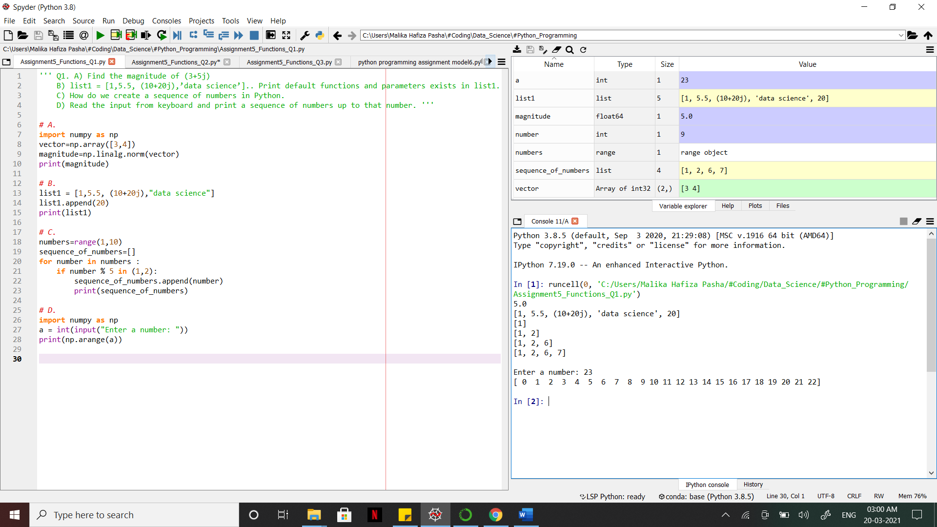

2. Write a simple user defined function that greets a person in such a way that:

i) It should accept both name of person and message you want to deliver.

ii) If no message is provided, it should greet a default message ‘How are you’

Ex: Hello ---xxxx---, How are you -🡪 default message.

Ex: Hello ---xxxx---, --xx your message xx---

**Answer:** [Python file is attached with the assignment file]

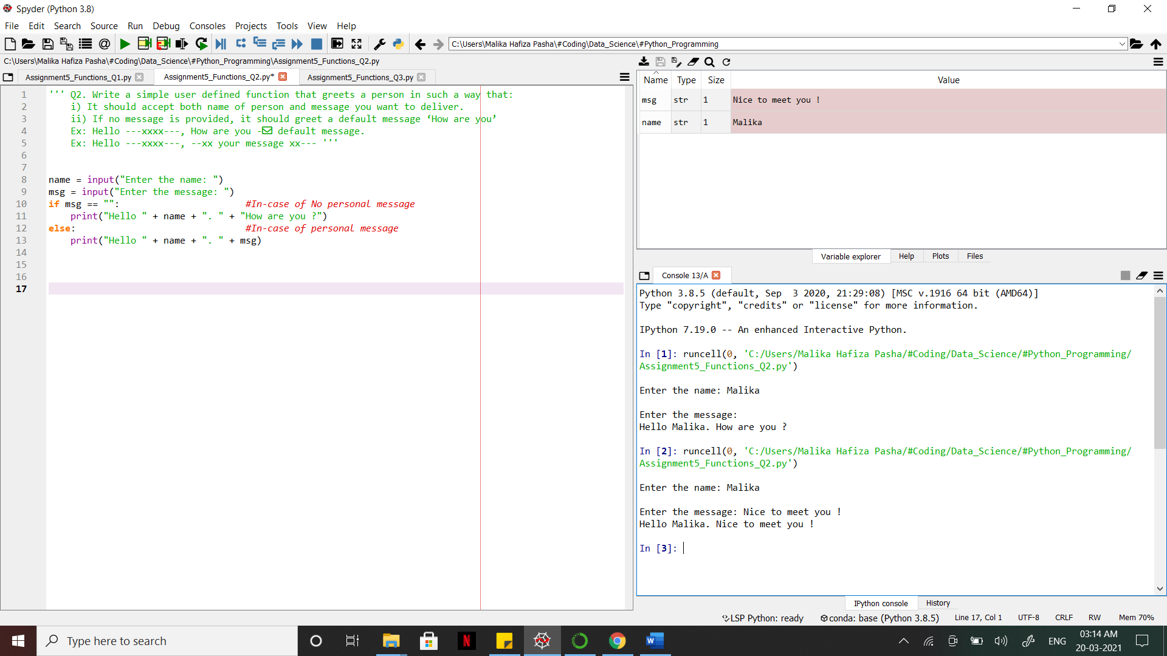

3.By using a filter function, find positive number present in a list.

Lsit1= [2, 6, -5, 4, -8, -9, 10, 1]

**Answer:** [Python file is attached with the assignment file]

